Stage 4 ★★
Mixed Selection 1 - Solutions

- Circled corners
The three angles of the triangle add to $180°$, so the combined area of the three sectors of the circles that are inside the triangle add up to half a circle with area:
$\frac{1}{2}×π×2^{2}=\frac{4π}{2}=2π$.
So the grey area is $\left(80-2π\right)cm^{2}$.

- Rolling inside
The circumference of the circle is $2π$. This is the distance its centre moves each time the circle rolls for one revolution. When the circle moves from one corner to an adjacent corner, its centre moves a distance 2, so the circle makes $1/π$ revolutions. As it needs to do this four times before the circle returns to its original position, the number of revolutions is $4/π$.

- Sticky tape
The cross section of the $20m$ tape has area $π\left(4^{2}-3^{2}\right)cm^{2}=7π cm^{2}.$ Therefore, the $80m$ tape should have a cross-section area $28π cm^{2}$. Hence, the outer radius of the $80m$ roll will be approximately $\sqrt{37}cm$.
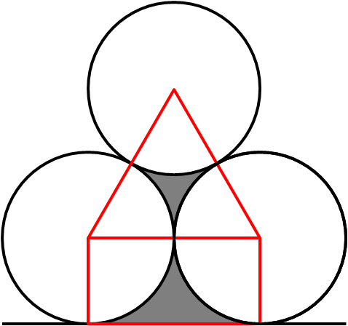
- Wood pile perimeter
The centres of the three circles form an equilateral triangle, so each of the sectors marked is $1/6$ of a circle. The shape below is a rectangle, so the sectors are $1/4$ of a circle. The curved portion of the perimeters is therefore the same as each of the circles: $2π×5=10πcm$.
The straight part is the same length as two radii, so is $10cm$ long.
The perimeter of the shaded shapes is therefore $(10+10π)cm$.

